Copyright
Photos, music and writing even on the internet usually have a copyright. A copyright means that you must ask permission to use the photo, music or writing. If you do not ask and receive permission, you could get into trouble. The law in the United States considers this a type of theft (stealing).
Fortunately in education, there are websites that offer free images (photos) and music for private non-commercial (non-business) use. That means that students can use the images and music for projects. Sometimes the image or music is free. Sometimes you will need to sign up for an account first. Be careful when you sign up with an account. The company may use your name and e-mail address for marketing. Make sure that you credit the photographer or musician if you are asked to do so.
1. Flickr is one of the best places on the internet to get images for your project. You will need to search for images with Creative Commons-licensed content to use in your project.
Go to http://www.flickr.com/
Type the name of something that you want to search for in the Search Box. For example, I typed “spring” in the search box. Hit the SEARCH button.
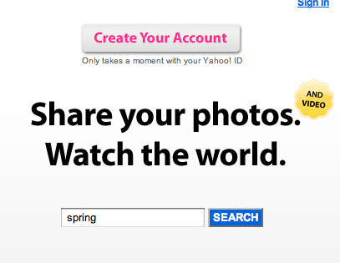
Next you will see photos along with another SEARCH box.
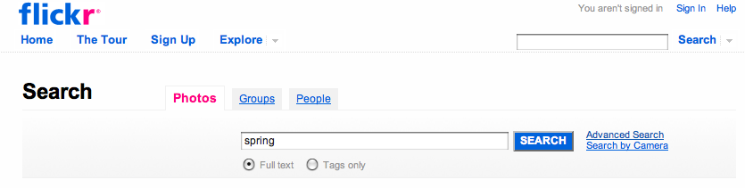
Now click on Advanced Search next to the SEARCH button. You will get a new page.
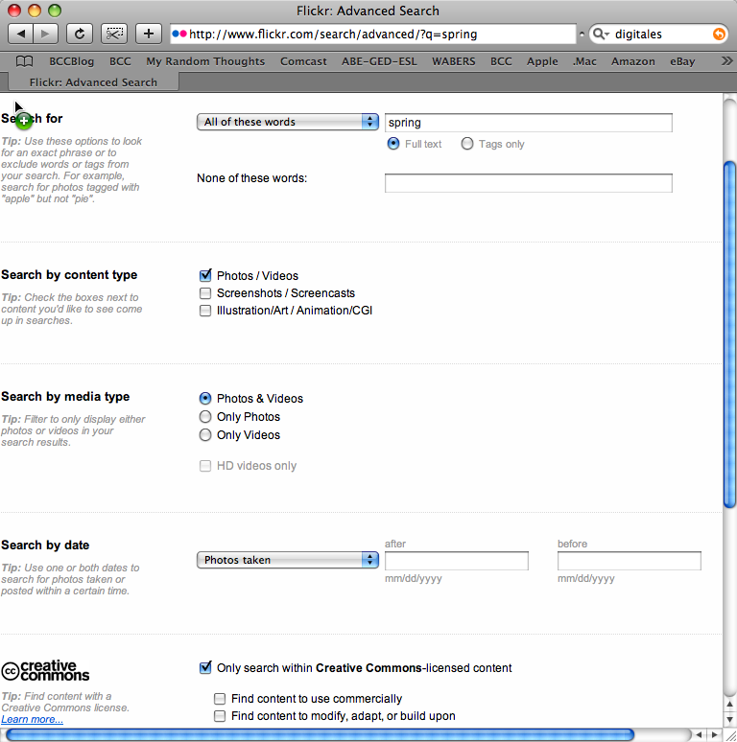
Scroll toward the bottom and check “Only search within Creative Commons-licensed content.
Then hit the SEARCH button. The photos that you see will be ones that you can use in your project. You must do this each time you do a new search.
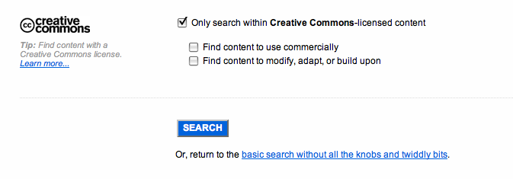
When you download, use medium-sized photos.
Music
Music can be downloaded at http://www.freemusicplay.com/
I also use Jamendo at http://www.jamendo.com/en
Once again be sure that you read the information on the website about the use of music or images. You may need to include screen credits to authors or photographers or websites as part of your permission to use the resources. Citing all resources is always a good idea for a project.

