iMovie 06 Tutorial
Adapted from Daniel Meadows, Online iMovie 06 Tutorial, Cardiff University, 2006.

Starting the iMovie 06 Project.
Open up iMovie by double clicking on the iMovie clapperboard icon .
Create new project the first time.
Name the project. Use your own name.
(After the first time, you will select Open Existing Project.)
When iMovie opens up, you will see three distinct areas.
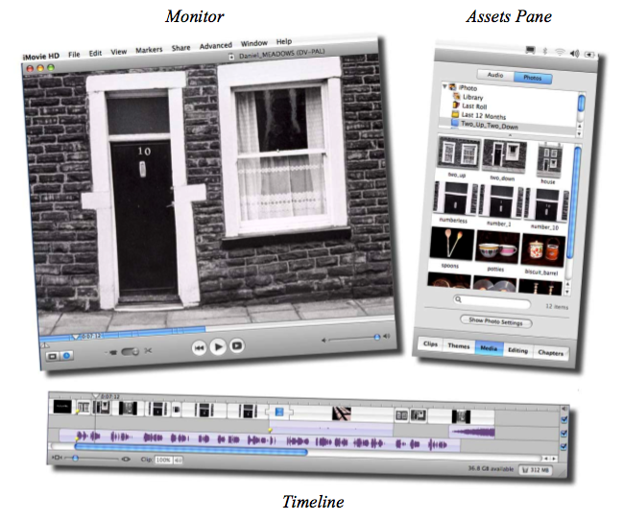

Assets Pane: This is also the place where we find the titles, transitions and effects that we can apply to photos once we have dragged them into the Timeline.

Timeline: We will drag the photos and voiceover directly to the timeline. Photos will be dragged to the uppermost track and the voiceover is dragged into one or other of the two lower tracks.

c) Monitor: this is where we view the Digital Story as it comes together.

Bringing the voiceover into iMovie HD.

To make a digital story in iMovie HD, we will line up pictures in the video track so that they match what is being said by the voice, and then we add effects and a title to make our story interesting.

Drag the voiceover to the timeline. Give it a few seconds to work. You will see the voiceover in purple. The audio waveform is a picture of your voice.

Important: In iMovie, select by clicking on the photo or waveform.
Deselect by clicking on the gray iMovie HD background.

It should look like this.
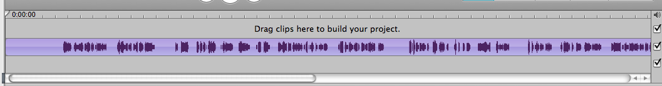

To hear your voice-over play, hit the spacebar to start playing the track, hit it again to stop playing the track. As the clip plays, the Playhead (a vertical line with a white
paddle-shaped pointer at its top) moves from left to right in the Timeline. You
can move along the Timeline to another part of the clip by clicking in the
Playhead Track which looks like this:

The Playhead will instantly jump to where you have clicked.

To view your Timeline from a distance or to zoom-in on any part of it, use the
Zoom Slider at bottom left of your window.

To zoom-in on your Timeline, move the Zoom Slider from left to right. To
zoom-out (that is, to get further away so that you can see more of, or all of, the
clip in the Timeline) move the Zoom slider right to left. Note that the
Timeline always centers itself on the position where you have placed the
Playhead.

If your audio sounds quiet when played, then adjust the volume control on
your keyboard (F5 key). If it still sounds quiet then adjust the volume control in iMovie HD by using the slider on the monitor: 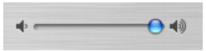

Adding the title
All movies begin with a title.
Move the playhead to 0:06:00. (Or as close as you can. )
Click to select the voice-over clip and, pointing in the middle of the clip (not at its
edge) click-drag it along the Timeline until you reach the place where the start of the
speaking voice comes to rest just after the ghosted Playhead position at 0:06:00.

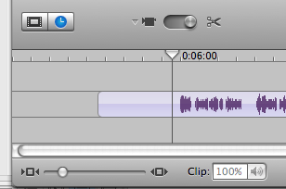
Next click on the Editing tab on assets pane.
Click on Titles on the top left of the assets pane.

Now, from the menu of possible title styles, choose Centered Title.
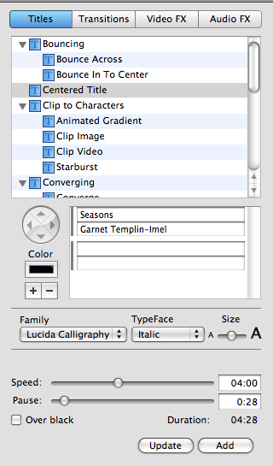

Text Boxes: In the middle of the Assets Pane there are two pairs of narrow
white Text Boxes. The default text is My Great Movie by test user Starring
Me. Change this for your own title. You can see I have typed Seasons in the first box and my name in the second.

Extra Information for advanced users: The wheel beside the Text Boxes allows you to set the direction an animated title will move. To the left of the boxes there is also a Color box to change font color (it opens the Colors palette if you click it) as well as a “+” and a “-“ button. Hit the “+” and a “-“ buttons to create or delete text boxes.

Controls: You can choose a font style in family, and a typeface and size for the title lettering.
Speed and Pause determine the way the Title appears and disappears.
Speed shows the amount of time for which your chosen effect
applies while Pause indicates the amount of time for which the words are on
the screen. Move the sliders until you like how the title appears. Make sure that 06:00 is the total of the two sliders.
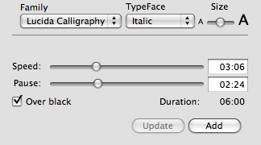
You can preview it each time. Look at the preview on the monitor. When you are happy that you have created your title correctly, click on the Add button . Your title is done. You will see it on the timeline. It should look like this.
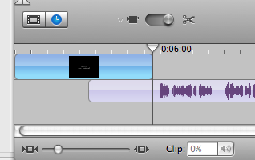
(Note: If later you don’t like the title, you can change it by using the Update button.)
Do a FILE > SAVE PROJECT.
Bringing Photos into iMovie HD
First go to View on the Toolbar. Open View. Then deselect Show Clip Volume Levels. (Deselect means that there is no check mark next to Show Clip Volume Levels.)

Make sure that the mode switch located on the Monitor is moved to the scissors icon.

Click on the clock on the monitor. This is the symbol for edit your work in the Timeline
Viewer. (If you click on the other button, you will see the clips.)
Click Media on assets pane.
Click Photos at the top of the assets pane.

Choose your photo album in iPhoto. You will see the pictures appear in the little panes.
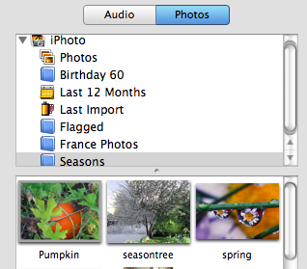
Click on a picture to select it.
The ìPhoto Settings box appears. Uncheck Ken Burns effect.

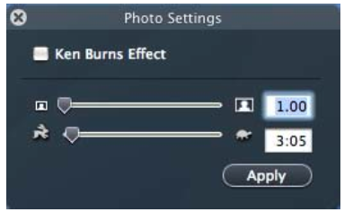

Photo Settings sliders. The Crop slider (the one with the small and bigger pictures of a head in a box) changes what you want to see in a photo. The Tortoise and the Hare slider control how long the photo shows on the screen.

Now you will apply a numerical value to your photos which will enable
you to see them easily in the Timeline . Once the photos are in the Timeline, you will Edge Drag each picture separately to fit with the voice track, extending or shortening the time for which it plays.

To set these values move the Crop Slider or type 1.00 into the Crop slider box (which tells iMovie HD that you want to see all of the picture and not just a cropped piece of it),
then hit the Enter key (or Return key) on your keyboard. Now move the Tortoise/Hare slider or type 2:00 into the Tortoise and the Hare box (which tells iMovie HD that you want it to give it a duration of two seconds) and hit the Enter key (or Return key) again.

Note: Do not click the Apply button. You will click-drag the photos from the Photos Pane into the Timeline one at a time.

Now click-drag your first photo to the timeline.

Notice is that your clip is selected (dark blue) and that the Playhead has moved to the l-h end of the clip ready to play it. Hit the spacebar and you will see the clip, and only the clip, play in the Timeline accompanied by your voice-over.
To see both the title and the photo clip play, deselect the clip by clicking anywhere on iMovie HD’s gray background, then click-drag the Playhead to the place where you want to start viewing your story; hit the spacebar. To stop it playing hit the spacebar again.

Your newly imported clip begins in the correct place, but it doesn’t end just where it should. You need to stretch it out or shrink it by Edge Dragging. (Important: Edge Dragging cannot happen if you have audio levels turned on. To switch audio levels off, go to VIEW > SHOW CLIP.)

To shrink or stretch a selected clip, move the Playhead to the place on the Timeline where you would like the clip to finish. Move your cursor to the r-h end of the photo clip. You will see the cursor turn into a bracket with arrows on it. Edge Drag the clip to stretch it out or shrink it. The moment you start the move, the Playhead leaps to the position of your cursor, leaving a ghosted image of itself in the place at which you want the clip to end.

Now go up to the Photo Pane to select your second picture. Drag your second picture into the Timeline and make the necessary adjustments as before. Repeat this process until all your pictures are in the right place in the Timeline.

Some notes:

a) Undo Command: Remember that, if you make a mistake, you can always do a
EDIT > UNDO. Also, each UNDO undoes one-at-a-time every step you have performed since the last time you saved your project. The Undo Command is your friend.

b) Deleting Clips: If you insert the wrong picture into the Timeline or you change
your mind about which picture should be there, you can delete it from the timeline by
clicking on it to select it and then hitting the Delete key. (Don’t worry. It won’t delete the picture from the photo pane.

c) The Ripple Effect: When you have several picture clips in the Timeline be careful when you make a change.

If you highlight a clip from the middle of the track to shorten it, and then move the cursor to its r-h end to begin a leftwards Edge Drag, you will see that the cursor turns into a bracket with two arrows on it, one pointing to the right, the other pointing to the left. If you now Edge Drag to shorten this clip, the following clips start moving leftwards
in the Timeline to fill the gap. This is bad news. Now your pictures will not match your voiceover. This same thing happens if you try to shorten a clip by Edge Dragging the l-h side. This is called the Ripple Effect.

To prevent the Ripple Effect you can create a temporary space between the
selected clip and its following (or previous) clips by Edge Dragging with the
Apple (or Command) key held down. A gray space then opens up
between the clips and, fortunately, everything else stays where it should. But
do this carefully!
Now, if you want, you can make the space you have created between the clips
into a blank black clip. You do this by Control-clicking (or right-clicking if
you’re using a two-button mouse) inside the space between the clips and,
when the shortcut menu appears, select CONVERT EMPTY SPACE TO
CLIP. If you decide to change the color of this clip, double-
click on it in the Timeline and the CLIP INFO window will open. Here you
can click COLOR to open the COLOR PICKER and so choose a new color.

d) Save Project: Do a FILE > SAVE PROJECT in iMovie HD only when you are sure you like your movie. When you do a SAVE, the UNDO memory is deleted and you can no longer change your recent edits.

e) Trash: You can open the Trash to retrieve deleted Timeline clips by double-clicking on the Trash icon at the bottom r-h corner of the iMovie HD window. Don’t empty the Trash unless you are finished and don’t want to change your movie. The FILE > EMPTY TRASH command also deletes the UNDO/REDO memory.

Now you are ready to add transitions, the Ken Burns effect, the music sound track and credits to make your movie look professional.

