Storyboard: Seasons by Garnet Templin-Imel
I love to observe seasonal changes. Seasons set the rhythm of my life.
In fall I gather gold, brown, orange, deep red, and rust maple leaves to decorate the house, and I prepare wonderful smelling food.
Winter begins with bright lights, happy people and music everywhere. After Christmas, though, the days get dark very early and the natural beauty of this region is asleep.
In spring, I enjoy getting out of doors to see the flowering plum and cherry trees. I clean my house inside and out.
The lazy summer gives me time to relax. The weather is often nice, and I can picnic and travel. I am sad to see summer come to an end, but then I remember that autumn is around the corner, and the leaves start to fall.

Title—Words over black | Seasons by Garnet Templin-Imel
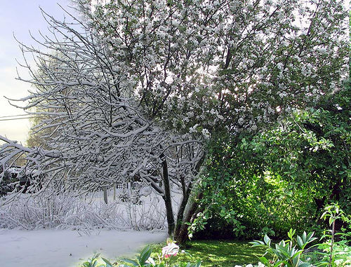 | I love to observe seasonal changes. Seasons set the rhythm of my life.
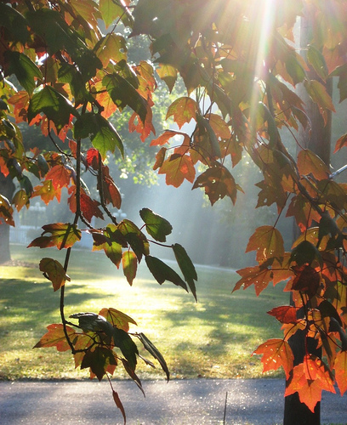 | In fall I gather gold, brown, orange, deep red, and rust maple leaves to decorate the house,
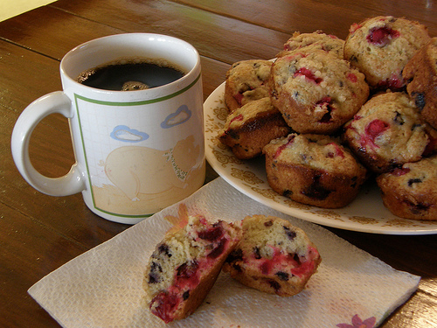 | and I prepare wonderful smelling food.
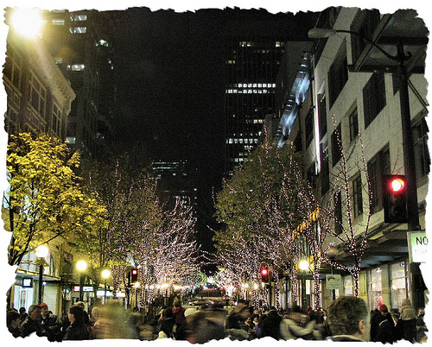 | Winter begins with bright lights, happy people and music everywhere.
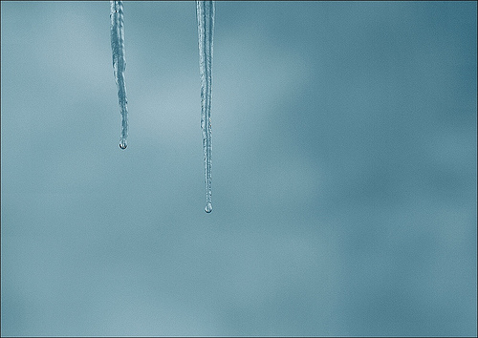 | After Christmas, though, the days get dark very early and the natural beauty of this region is asleep.
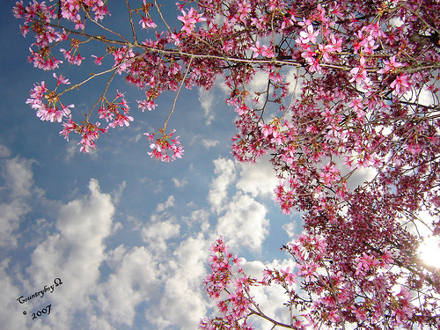 | In spring, I enjoy getting out of doors to see the flowering plum and cherry trees.
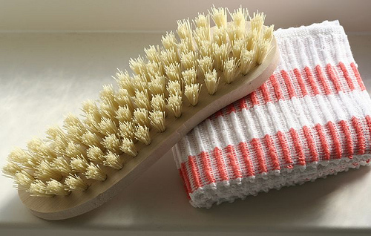 | I clean my house inside and out.
 | The lazy summer gives me time to relax. The weather is often nice,
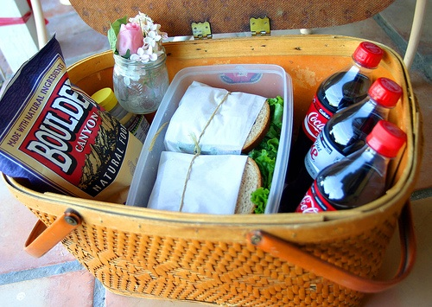 | and I can picnic and travel.
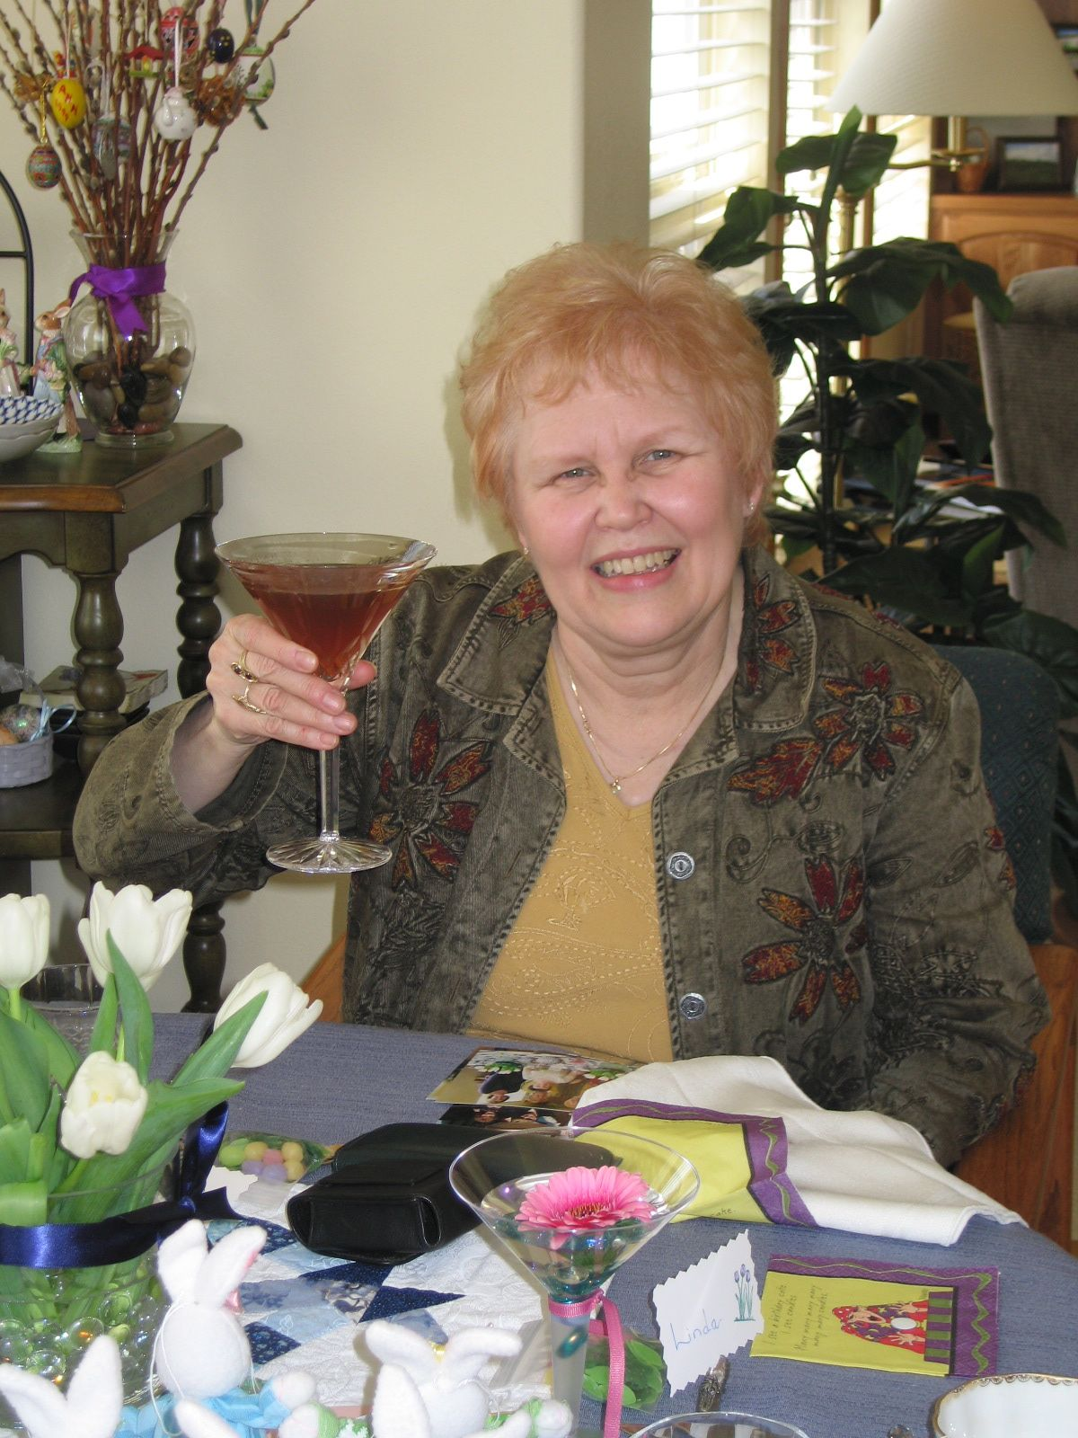 | I am sad to see summer come to an end, but then I remember that autumn is around the corner,
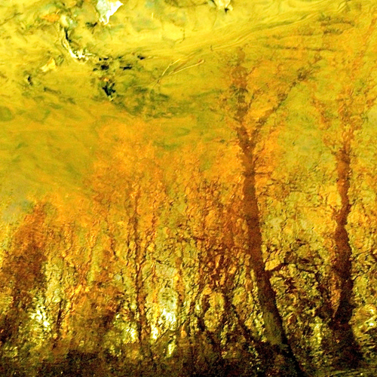 | and the leaves start to fall.
Credits—Words over black | Music by Maya Filipič  Selection: Stories from Emona III  Seasons written by Garnet Templin-Imel

